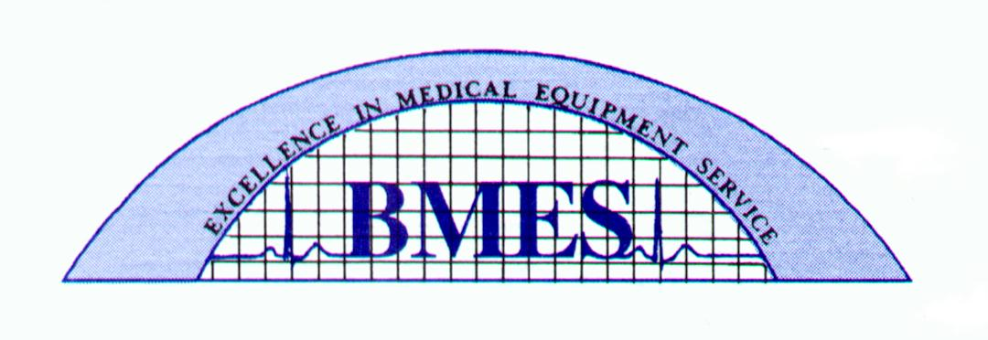

APEX PROBLEM SOLVING GUIDE
STEP 1 Replace leadset with known good leadset.
STEP 2 Replace batteries with known good batteries..
STEP 3 Check and make sure that transmitter and central station programmed TTX numbers are correct.
Example:
Transmitter and receiver are both programmable. If the TTX# on the transmitter is 123 then at the central station you must make sure that you have selected TTX#123 for that sector.
STEP 4 Make sure the sector you are working with is selected and has the patient admitted.
STEP 5 If all above problem solving suggestions have failed, please send transmitter to BMES for repair.
BMES
800-626-4515 Technical Support
8505 Nash rd
Louisville, KY 40214

